300mW RGB 3D Animation Laser with LED
User Manual

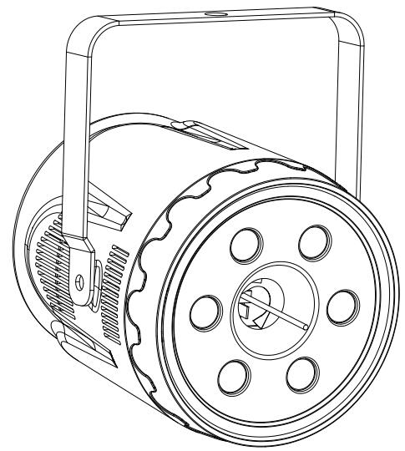

Please read this manual carefully before use!

Contents

Introduction----------------------------------------------------------------------------------------P2

Silkscreen on product--------------------------------------------------------------------------P3

Safety instruction/Installation/Technical specification------------------------------P4

MENU-------------------------------------------------------------------------------------------------P5

DMX512 Channel-------------------------------------------------------------------------------P5-8

DMX512 connection-----------------------------------------------------------------------------P8

DMX address setting/Ringing----------------------------------------------------------------P9

Cleaning and maintenance/Warning----------------------------------------------------- P10

Warranty card------------------------------------------------------------------------------------P11

Introduction
Thank you for purchasing this product. To optimize the performance of this product,prior to use,please read these operating instructions carefully to familiarize yourself with the basic operation of this unit.Please keep the manual in safe price for future reference.
This unit has been tested at our factory before being shipped to you, there is no assembly required.
Once after received this product , please take and put carefully. And check cautiously that whether the product was damaged or not during the transportation.

Checking Parts
Please check if the following parts are included:
1 x Laser light
1 x User manual
1 x Power cable

Caution



CAUTION!

Keep this device away from rain and moisture!

Unplug mains lead before opening the housing!

Warning!


Damages caused by the disregard of this user manual are not subject to warranty. The dealer will not accept liability for any resulting defects or problems.

Symbol Instruction On The Device

…


-------------------------------------------------------------------------------CE Certificate
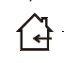

---------------------------------------------------------------------Only indoor use



------------------------------------------------------------------------Environmental protection

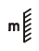
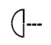
----------------------------------------The minimum distance from lighted objects(meter)

------------------------------------------------------------Max. Ambient Temp

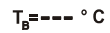
----------------------------------------------------Max. Housing Temp



------------------------------------------------------------------------- Safety caution



-------------------------------------------------------------------------Careful burns



------------------------------------------------------------------------Careful electric shock

-----Not suitable for directly installed on the surface of ordinary combustible materials

Safety Instructions
- Please open and check whether break or not for transport once receive this fixture, if yes, not use it and contact dealer or manufacture as soon as possible.
- The Max applicable temperature for the light is 40°C. Do not use the light under or above the temperature. ta=40℃
- The fixture is applicable for many occasions, it should keep clean, and avoid long use in overheating or dusty environment. To prevent the fixture from the chemical liquid .
- User must be careful of fire, heat, electric and fall-off that make heavy or fatal injury. Please read this user manual carefully before power on and installation, following safety and operation instruction in it. If still have any questions, please contact dealer or manufacture.
- User must following this user manual, do not open fixture by yourself, if any problems, please contact professional technician, maintenance should by technician.
Do not power on or start the fixture before installation, please stop after working more than 8 hours, which will longer use life.
- Fixed installation, do not by strong shocks.
- The minimum distance between light and the illuminated surface must be more than 1 meter. 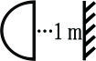
- Never look directly into the light source to avoid hurt to eyes (especially epileptics)!
When dustproof glass at light output breaks, cracks or other visible damage, user should replace with new glass to continue to use.

Installation
- When install this equipment please make sure there's no flammable surfaces (decorated things, etc) and minimum distance of 0.5M from the equipment to the flammable.

- The installation of the effect has to be built and constructed in a way that it can hold 10 times the weight and without any harming deformation.
- The installation must always be secured with a secondary safety attachment, e.g. an appropriate safety rope.Never stand directly below the device when mounting, removing or servicing the fixture.

Technical Specifications
Input voltage: AC100-240V, 50/60Hz
Fuse: 250VAC F2A
Total power:50W
Laser source: 300mW(R:100mW/638nm+G:50mW/520nm+B:150mW/450nm)
LED source: 6*3W RGBW LEDs
Control mode: Auto/Sound/DMX512/Master-slave
Channels：7/21 CH
Scanning system: 15Kpps Scanner, ±20º
216 static+248 dynamic internal patterns for show
Grating wheel: 11+1
Surface temp: Tb=45ºC ( this data testing when the environment temp is 30ºC)
Working temp: 10ºC--65ºC
Modulation: Analog
N.W: 2.1Kg
Product size: 210*217*235mm(with bracket)

Laser control system
1. MENU display
MENU | Display | Function
Addr | 1-512 | DMX address setting
CHND | 21CH | DMX Channel 21CH
CHND | 7CH | DMX Channel 7CH
AUTO | AU 0--AU 15 | AU 0 Random auto; AU1-AU 15 Auto effect groups option
SPEED | 0-9 | Auto mode with speed adjust
SENSE | 0-9 | Sound sensitivity
VERSION | Ver1.0 | Software version

DMX Channel Instructions

7CH

Channel | Function | Value | Details
CH1 | Dimmer | 0-9 | No function
CH1 | Dimmer | 10-255 | Total dimmer, laser on and LED for dimmer
CH2 | Strobe | 0-9 | LED No function
CH2 | Strobe | 10-255 | LED Strobe from slow to fast
CH3 | LED color control | 0-9 | LED No function
CH3 | LED color control | 10-79 | LED color marco
CH3 | LED color control | 80-159 | LED jump from slow to fast
CH3 | LED color control | 160-255 | LED gradual change from slow to fast
CH4 | Laser color control | 0-1 | Laser off
CH4 | Laser color control | 2-69 | W-R--B-P-CYAN-Y-G (Fixed color)
CH4 | Laser color control | 70-79 | Total color change ( eotic speed controlled by CH5)
CH4 | Laser color control | 80-89 | Default color (Eotic speed controlled by CH5)
CH4 | Laser color control | 90-94 | Rainbow color (Eotic speed controlled by CH5)
CH4 | Laser color control | 95-114 | - Segement color option, 5 datas as one step  (eotic speed controlled by CH5)
CH4 | Laser color control | 115-139 | - Segement color option, 5 datas as one step  (eotic speed controlled by CH5)
CH4 | Laser color control | 140-164 | - Segement color option, 5 datas as one step  (eotic speed controlled by CH5)
CH4 | Laser color control | 165-189 | 8-Segement color option, 5 datas as one step  (eotic speed controlled by CH5)
CH4 | Laser color control | 190-224 | 16-Segement color option, 5 datas as one step  (eotic speed controlled by CH5)
CH4 | Laser color control | 225-229 | Color dynamic eotic 1 (eotic speed controlled by CH5)
CH4 | Laser color control | 230-234 | Color dynamic eotic 2 (eotic speed controlled by CH5)
CH4 | Laser color control | 235-239 | Color dynamic eotic 3 (eotic speed controlled by CH5)
CH4 | Laser color control | 240-244 | Color dynamic eotic 4 (eotic speed controlled by CH5)
CH4 | Laser color control | 245-249 | Color dynamic eotic 5 (eotic speed controlled by CH5)
CH4 | Laser color control | 250-255 | Color dynamic eotic 6 (eotic speed controlled by CH5)
CH5 | Color eotic speed | 0-9 | No function
CH5 | Color eotic speed | 10-127 | Clockwise color eotic from slow to fast
CH5 | Color eotic speed | 128-255 | Anti-clockwise color eotic from slow to fast
CH6 | Inner dynamic effect | 0-1 | No function
CH6 | Inner dynamic effect | 3-183 | Inner dynamic effect single option, 2 datas as one effect, speed and color controlled by CH7
CH6 | Inner dynamic effect | 184-248 | Inner dynamic effect group option, 5 datas as one effect, speed and color controlled by CH7
CH6 | Inner dynamic effect | 249-255 | Random auto, speed and color controlled by CH7
CH7 | Inner dynamic effect speed | 0-127 | Speed from fast to slow by inner programme
CH7 | Inner dynamic effect speed | 128-255 | Speed from fast to slow by DMX controller

21CH

Channel | Function | Value | Details
CH1 | Dimmer | 0-9 | No function
CH1 | Dimmer | 10-255 | Total dimmer, laser on and LED for dimmer
CH2 | Strobe | 0-9 | LED No function
CH2 | Strobe | 10-255 | LED Strobe from slow to fast
CH3 | LED color control | 0-9 | LED No function
CH3 | LED color control | 10-79 | LED color marco
CH3 | LED color control | 80-159 | LED jump from slow to fast
CH3 | LED color control | 160-255 | LED gradual change from slow to fast
CH4 | Laser color control | 0-1 | Laser off
CH4 | Laser color control | 2-69 | W-R--B-P-CYAN-Y-G (Fixed color)
CH4 | Laser color control | 70-79 | Total color change ( eotic speed controlled by CH5)
CH4 | Laser color control | 80-89 | Default color (Eotic speed controlled by CH5)
CH4 | Laser color control | 90-94 | Rainbow color (Eotic speed controlled by CH5)
CH4 | Laser color control | 95-114 | - Segement color option, 5 datas as one step  (eotic speed controlled by CH5)
CH4 | Laser color control | 115-139 | - Segement color option, 5 datas as one step  (eotic speed controlled by CH5)
CH4 | Laser color control | 140-164 | - Segement color option, 5 datas as one step  (eotic speed controlled by CH5)
CH4 | Laser color control | 165-189 | 8-Segement color option, 5 datas as one step  (eotic speed controlled by CH5)
CH4 | Laser color control | 190-224 | 16-Segement color option, 5 datas as one step  (eotic speed controlled by CH5)
CH4 | Laser color control | 225-229 | Color dynamic eotic 1 (eotic speed controlled by CH5)
CH4 | Laser color control | 230-234 | Color dynamic eotic 2 (eotic speed controlled by CH5)
CH4 | Laser color control | 235-239 | Color dynamic eotic 3 (eotic speed controlled by CH5)
CH4 | Laser color control | 240-244 | Color dynamic eotic 4 (eotic speed controlled by CH5)
CH4 | Laser color control | 245-249 | Color dynamic eotic 5 (eotic speed controlled by CH5)
CH4 | Laser color control | 250-255 | Color dynamic eotic 6 (eotic speed controlled by CH5)
CH5 | Color eotic speed | 0-9 | No function
CH5 | Color eotic speed | 10-127 | Clockwise color eotic from slow to fast
CH5 | Color eotic speed | 128-255 | Anti-clockwise color eotic from slow to fast
CH6 | Patterns option | 0-255 | Patterns option (patterns group controlled by CH7)
CH7 | Patterns group option | 0-24 | Inner patterns group 1
CH7 | Patterns group option | 25-49 | Inner patterns group 2
CH7 | Patterns group option | 50-74 | Inner patterns group 3
CH7 | Patterns group option | 75-99 | Inner patterns group 4
CH7 | Patterns group option | 100-124 | Inner patterns group 5
CH7 | Patterns group option | 125-149 | Dynamic patterns group 1
CH7 | Patterns group option | 150-174 | Dynamic patterns group 2
CH7 | Patterns group option | 175-255 | No function
CH8 | Pattern size | 0-255 | Pattern size option by manual
CH9 | Pattern auto zoom | 0-15 | Pattern size option
CH9 | Pattern auto zoom | 16-55 | From small to big speed option
CH9 | Pattern auto zoom | 56-95 | From big to small speed option
CH9 | Pattern auto zoom | 96-135 | Big and small zoom speed option
CH9 | Pattern auto zoom | 136-175 | Cycle zoom effect 1
CH9 | Pattern auto zoom | 176-215 | Cycle zoom effect 2
CH9 | Pattern auto zoom | 216-255 | Cycle zoom effect 3
CH10 | Patterns middle rotation | 0-127 | Rotation angle option
CH10 | Patterns middle rotation | 128-191 | Clockwise rotation speed option
CH10 | Patterns middle rotation | 192-255 | Anti-clockwise rotation speed option
CH11 | Patterns X rotation | 0-127 | X location option
CH11 | Patterns X rotation | 128-255 | X speed option
CH12 | Patterns Y rotation | 0-127 | Y location option
CH12 | Patterns Y rotation | 128-255 | Y speed option
CH13 | Horizontal remove | 0-127 | Horizontal location option
CH13 | Horizontal remove | 128-255 | Horizontal remove speed from slow to fast
CH14 | Vertical remove | 0-127 | Vertical location option
CH14 | Vertical remove | 128-255 | Vertical remove speed from slow to fast
CH15 | X wave | 0-9 | No function
CH15 | X wave | 10-255 | Wave range and speed adjust
CH16 | Patterns drawing | 0-1 | No function
CH16 | Patterns drawing | 2-63 | Manual drawing 1
CH16 | Patterns drawing | 64-127 | Manual drawing 2
CH16 | Patterns drawing | 128-153 | Auto drawing increase
CH16 | Patterns drawing | 154-179 | Auto drawing decrease
CH16 | Patterns drawing | 180-205 | Auto drawing, reverse from increase to decrease
CH16 | Patterns drawing | 206-255 | Auto drawing, syntropy from increase to decrease
CH17 | Patterns trace option | 0-15 | No function
CH17 | Patterns trace option | 166-255 | Trace option, range from big to small
CH18 | Trace speed | 0-255 | Trace speed from slow to fast
CH19 | Gobo wheel | 0-255 | Laser gobos wheel change
CH20 | Inner dynamic effect | 0-1 | No function
CH20 | Inner dynamic effect | 3-183 | Inner dynamic effect single option, 2 datas as one effect, speed and color controlled by CH21
CH20 | Inner dynamic effect | 184-248 | Inner dynamic effect group option, 5 datas as one effect, speed and color controlled by CH21
CH20 | Inner dynamic effect | 249-255 | Random auto, speed and color controlled by CH21
CH21 | Inner dynamic effect speed | 0-127 | Speed from fast to slow by inner programme
CH21 | Inner dynamic effect speed | 128-255 | Speed from fast to slow by DMX controller

DMX-512 connection
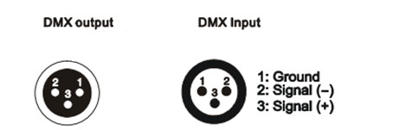

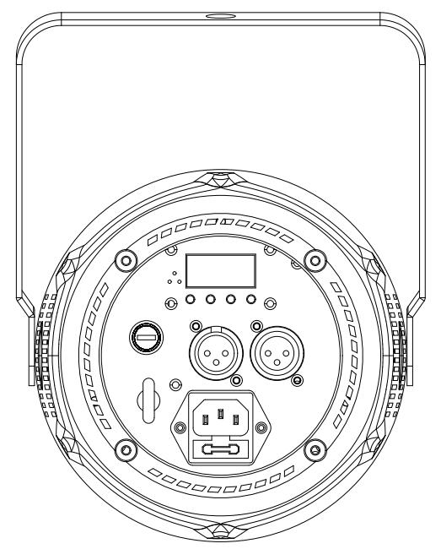

DMX In To the fourth
First light (Address 001) Second light (Address 022) Third light(Address 043)

DMX Address setting
Each fixture must set a specific starting address. When receiving signal transmission, fixture will receive channel control signals which from the starting address.
According to different requirements or easy to use, the user can set many value fixtures to the same address, also can set up a separate address for every device.
If you set the same address,all the devices will receive from DMX channels signal. All connecting fixtures are jointly controlled, controller can't separate control a device.
If you set a different address, each device will be separate from its particular set the starting address and begin accepting DMX512 control signal, so that more convenient separate control one device. Using this method must be based on channel quantity of device to determine a starting address.
This laser light has 21 channels.you should set the starting address of the first unit to 1, the second unit to 22(1 + 21), the third unit to 43 (21*2+ 1), and so on.

Ringing
1 Mounting bracket
2 Handle
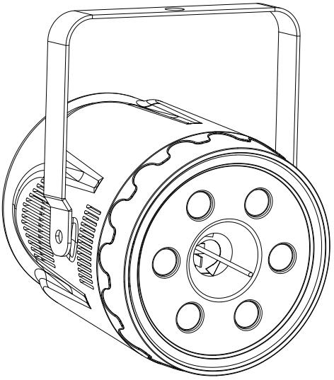

- .The ambient temperature range is 1°C--45°C, must never be exceeded.
- .The installation of the projector has to be built and constructed in a way that it can hold 10 times the weight for 1 hour without any harming deformation.
- ).When rigging or servicing the fixture staying in the area below the installation place, on bridges,under high working places and other endangered areas is forbidden.
D).The operator has to make sure that safety-relating and machine-technical installations are approved by an expert before taking into operation for the first time and after changes before taking into operation another time.
E).The operator has to make sure that safety-relating and machine-technical installations are approved by a skilled person once a year.
F). Sure M8 screws on mounting bracket fixed middle hole ¢12.5mm of handle
Cleaning and maintenance

Maintenance should be performed every 15-day period, by using a sponge which is dipped with alcohol, rather than wet cloth or other chemical liquid, to clean the mirror.

Always disconnect from the mains when the device is not in use or before cleaning it.

Caution
Make sure power off before cleaning and maintenance!

Warning

Warning!
Never look directly into the light source,as sensitive persons may suffer an epileptic shock(especially meant for epileptics)!
Caution

Warning!
Any power connected must by professional person


Warranty Card
This product is made of high-brightness transistor. We will provide 1 year warranty under the condition that user has operated the light normally and lifetime service. We won't provide warranty if the damage is caused by artificial or force majeure event. Cost of fittings should be charged by user if product need maintenance after 1 year .Please cut this warranty card and shipped it along with the product to our factory when applying for warranty.
Product：
Purchasing date：
Code of invoice：
Warranty date: From To
User’s name： Add：
Company： Tel：

